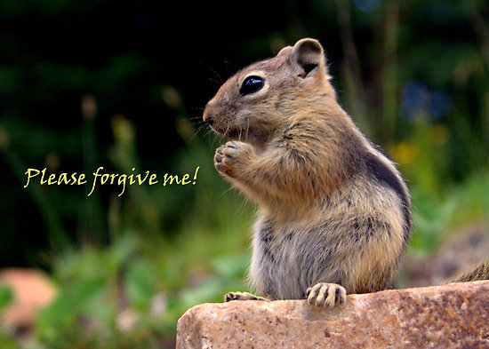

**(SAYING SORRY)**

1.

- I’m really sorry I’m late, Mr. Simpson. Please forgive me for keeping you waiting. The traffic is awful this morning.

- That’s all right. No problem. Come in, take your seat and join our discussion.

2.

- I’m terribly sorry, Lara. I forgot about your birthday because of my exams. Shame on me!

- Never mind. Don’t worry about it. Nobody congratulated me this time.

- Oh, sorry for making you sad on such a day. I realize my mistake.

3.

- I’m sorry about my bad behaviour. Now I regret it. It was wrong of me to lie to you.

- It’s hard to believe it but I forgive you. Please don’t do it next time.

- I promise I will never do it again. And I hope you can forgive me.

4.

- Please excuse the mess in your house and I really apologize for breaking your window. I didn’t do that on purpose.

- Apology accepted. But you must clear up the mess and buy and fix a new window.

- It goes without saying.

5.

- Please, accept my sincerest apologies for being rude to you. I didn’t mean it. Forgive me for hurting you.

- No need to apologize. Let’s forget it. I do hope we can still be friends. We should let bygones be bygones.